Word 2016 Essentials

Participants will gain a fundamental understanding of the Microsoft Word environment and the ability to complete tasks independently. They will demonstrate the correct application of the principle features of Word 2016 by creating and editing documents for a variety of purposes and situations. Document examples include professional looking reports, multi-column newsletters, resumes, and business correspondence.

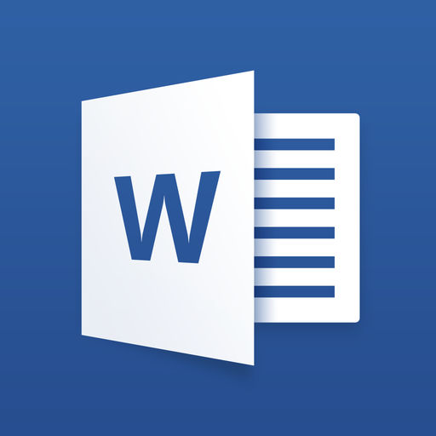
Workshop Objectives:
- Create and manage documents
- Format text, paragraphs, and sections
- Create tables and lists
- Create and manage references
- Insert and format graphic elements
Native Education & Training College
www.nativetc.com

