Adult Learner: Mental Skills

Bloom’s Taxonomy is not just for elementary school teachers. The three domains of the taxonomy apply to adult education as well. In this manual, we will pay attention to the cognitive domain. This is the domain of knowledge and intellect, and it is the main focus of most educators.
With our “Adult Learner: Bloom’s Taxonomy – Cognitive Domain” workshop, your participants will discover the specifics of how the cognitive domain increases intellectual capability.

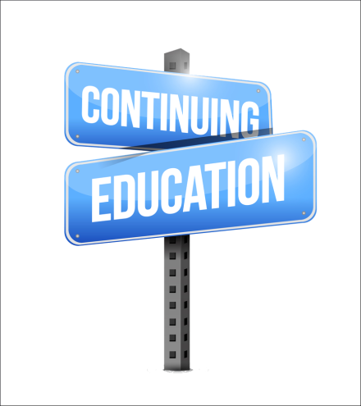
Workshop Objectives:
- Understand Bloom’s Taxonomy
- Explain the cognitive domain
- Explore the two cognitive domains
- Explain types of knowledge
- Identify training in the cognitive domain
Native Education & Training College
www.nativetc.com

